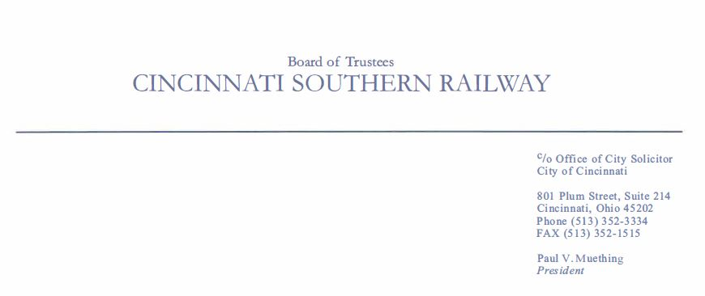

Statement
Paul V. Muething, Chair,
Cincinnati Southern Railway Board of Trustees
Resolution Agreeing to Terms of Sale of Cincinnati Southern Railway
CINCINNATI, OH – November 21, 2022: On behalf of the Board of Trustees of the Cincinnati Southern Railway, I am proud to announce the execution of a purchase and sale agreement with Norfolk Southern Railway Company, an operating subsidiary of Norfolk Southern Corporation (NYSE: NSC), to acquire all of the assets of Cincinnati Southern Railway.
The current Board of Trustees, and those who have served before us, have taken great care and pride in our stewardship of the Cincinnati Southern Railway. This transaction gives us the ability to deliver transformative and perpetual value to the City and its citizens.
The purchase price, including transaction fees, of approximately $1.62 billion is to be placed in a trust that will grow in perpetuity under the direction of the Cincinnati Southern Railway Board of Trustees. An income-producing asset for the City of Cincinnati, trust proceeds will be used by the City of Cincinnati for funding the rehabilitation or modernization of existing infrastructure, such as roads, bridges, parks, recreation facilities and other infrastructure necessary for delivering core public services.
We deeply appreciate the principled leadership and support provided by Mayor Aftab Pureval, and his predecessor John Cranley, during our long negotiations with Norfolk Southern. We agree with Mayor Pureval that, “This is an historic opportunity to deliver great value to the citizens of Cincinnati and realize a substantial return on the investment and foresight of our predecessors.” We also deeply appreciate the leadership of Norfolk Southern for their professionalism as we came to this historic agreement.
Closing of the sale is subject to approval by the voters of the City of Cincinnati, regulatory clearance from the U.S. Surface Transportation Board and passage of state law changes enabling the establishment of a trust.
A Norfolk Southern operating subsidiary has leased use of the Cincinnati Southern Railway for more than 140 years. The current term of the lease agreement began in 1987 and expires in 2026. Negotiations on a new lease agreement or sale of the railway began several years ago.
(more)
Currently, lease proceeds and other associated payments generate approximately $26 million annually for the City.
The City of Cincinnati is the only municipality in the country to own an interstate railroad. You can learn more about the Cincinnati Southern Railway at: www.cincinnatisouthernrailway.org.
# # #
Media Contact:
Nicholas J. Vehr, Vehr Communications
T: (513) 381-8347
E: nvehr@vehrcommunications.com

